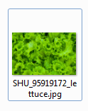

Caption ID of Parent: 1296660

Source: Shutterstock

Source ID: 95919172

Rights Type: Royalty Free

Credit: © dinodentist/Shutterstock

K12 Credit: Lettuce leaves. © dinodentist/Shutterstock

RM Assets Embedded: No

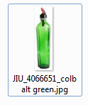

Caption ID of Parent: 175796

Source: Jupiterimages

Source ID: 4066651

Rights Type: Royalty Free

Credit: © Jupiterimages

K12 Credit: Green glass. © Jupiterimages

RM Assets Embedded: No

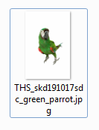

Caption ID of Parent: 1277564

Source: Thinkstock

Source ID: skd191017sdc

Rights Type: Royalty Free

Credit: © George Doyle and Ciaran Griffin/Thinkstock

K12 Credit: Green parrot. © George Doyle and Ciaran Griffin/Thinkstock

RM Assets Embedded: No

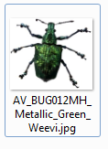

Caption ID of Parent: 114921

Source: Artville

Source ID: BUG012MH

Rights Type: Royalty Free

Credit: © Artville

K12 Credit: Weevil. © Artville

RM Assets Embedded: No



Caption ID of Parent: 110560

Source: Photodisc

Source ID: OS19074

Rights Type: Royalty Free

Credit: © Photodisc

K12 Credit: Green bowler hat and bowtie. © Photodisc

RM Assets Embedded: No

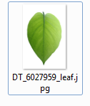

Caption ID of Parent: 219171

Source: Dreamstime

Source ID: 6027959

Rights Type: Royalty Free

Credit: © Bimarto Sasri/Dreamstime.com

K12 Credit: Green leaf. © Bimarto Sasri/Dreamstime.com

RM Assets Embedded: No

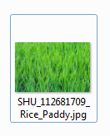

Caption ID of Parent: 1356744

Source: Shutterstock

Source ID: 112681709

Rights Type: Royalty Free

Credit: © Chris T Pehlivan/Shutterstock.com

K12 Credit: Rice paddy. © Chris T Pehlivan/Shutterstock.com

RM Assets Embedded: No

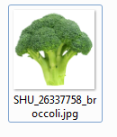

Caption ID of Parent: 1294696

Source: Shutterstock

Source ID: 26337758

Rights Type: Royalty Free

Credit: © Betacam-SP/Shutterstock

K12 Credit: Broccoli. © Betacam-SP/Shutterstock

RM Assets Embedded: No



Caption ID of Parent: 1280153

Source: Shutterstock

Source ID: 92345050

Rights Type: Royalty Free

Credit: © MarishaSha/Shutterstock

K12 Credit: Rubber frog. © MarishaSha/Shutterstock

RM Assets Embedded: No